NAME | John Oyetola
SPECIALISM | (UI) Web Designer / (UX) Programmer
TARGET GRADE | Distinction

Note: When filling in your development log be sure to include plenty of detail into what
you have done each week. Include images of your work to help explain what you produced.
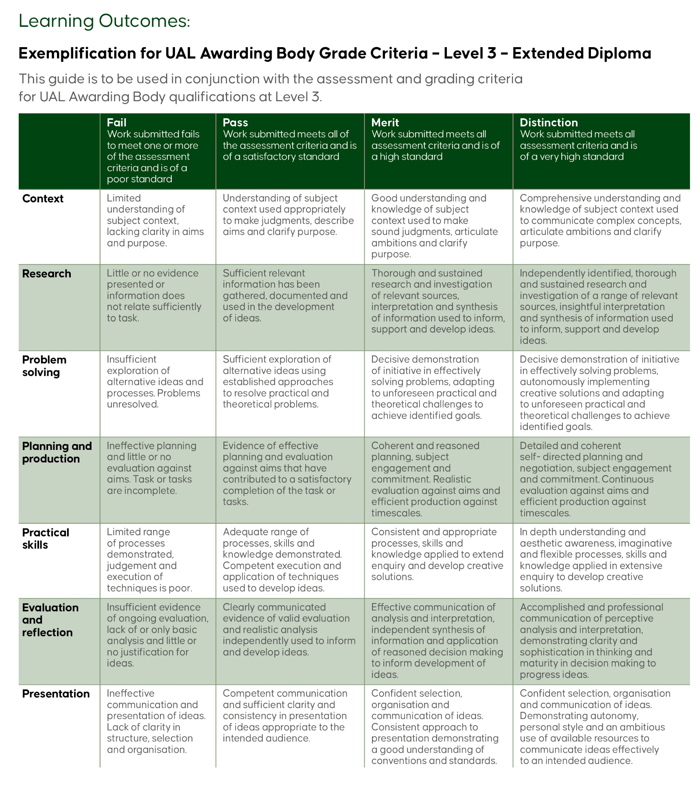
Week 1 (750 words) | 06/03/2026
Reflection | Tutor Feedback
Your weekly reflection should include the following:  - A description of what happened this week. Include screenshots to help explain what you did.  - If you used any software / tools, explain what and why you used it.  - How did you feel this week went. What went well, what did not.  - Were there any issues you had this week and did you find a solution?  - Any further research you did and how did you use it to help you.  - What was your SMART target from last week? Did you complete it? If not why?  - How did my work this week connect to the overall project goals?  - What feedback did I receive, and how did I respond to it?  - What would I do differently next time?  - What are my priorities or goals for next week | Where is last week reflection, make sure this is complete along with this week. As it adds to your overall grade.  Make sure you complete smart target and update the date.
This week was all about getting myself set up and understanding exactly what the Final Major Project involves. I spent a good amount of time going through the client brief for Hey Service Group properly so I knew what I was actually building before I jumped into anything.

I set up my Trello board straight away and mapped out the 12 weeks so I had a clear plan and wouldn't lose track of the May 22nd deadline. I also got my Figma board ready and organised my project folders on Teams so everything was in the right place from the start.

If I'm honest, I felt pretty motivated at the start of this week. The project is clearly a big one with a lot of requirements but having a plan laid out helped me feel more in control. The main thing I took from this week is that staying organised from day one is really important, especially with how much there is to cover.
Trello Update
Take a screenshot of your Trello board. This should be updated weekly therefore visually some changes. Write what you had done this week and what changes you have made to the board.
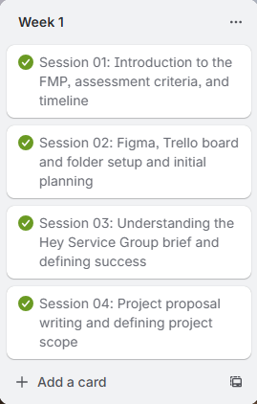

Smart Target
Your smart target should be broken down, providing clear targets for the following week.
Specific: I will begin my research into Hey Service Group, their competitors, and their target audience so I have a solid foundation before any designing starts.

Measurable: This will be done when I have documented notes on at least three competitors and a clear understanding of who the website is aimed at.

Achievable: This is a realistic first step as it only requires research tools I already have access to.

Relevant: This is essential to the project as I cannot design a good website without understanding the client and their audience first.

Week 2 (750 words) | 13/03/2026
Reflection | Tutor Feedback
Your weekly reflection should include the following:  - A description of what happened this week. Include screenshots to help explain what you did.  - If you used any software / tools, explain what and why you used it.  - How did you feel this week went. What went well, what did not.  - Were there any issues you had this week and did you find a solution?  - Any further research you did and how did you use it to help you.  - What was your SMART target from last week? Did you complete it? If not why?  - How did my work this week connect to the overall project goals?  - What feedback did I receive, and how did I respond to it?  - What would I do differently next time?  - What are my priorities or goals for next week | Complete last week reflections
This week I focused on doing research for the project. I started by looking into Hey Service Group as a company — what they do, who their clients are, and what they actually needed from the website. I also looked at their competitors to see how similar companies present themselves online and what I could do differently or better.

One thing I noticed straight away was that a lot of these websites had way too much text. It made them hard to read and not very user friendly. I wanted to make sure the Hey Service Group website didn't fall into that same trap, especially for the dashboard where managers need to see information quickly.

A big part of my research this week was looking at dashboard designs. I looked at Apple dashboards and Dribbble to get inspiration for how to display information visually. I liked how they used images and visual elements instead of just walls of text. That's the direction I decided to go with — using visuals and simple indicators to show data so anyone can understand it at a glance without needing to read loads of text.

Overall this week went well. It was slow because there was nothing visual to show for it yet, but I know this research is what will make the actual design much better later on.
Trello Update
Take a screenshot of your Trello board. This should be updated weekly therefore visually some changes. Write what you had done this week and what changes you have made to the board.
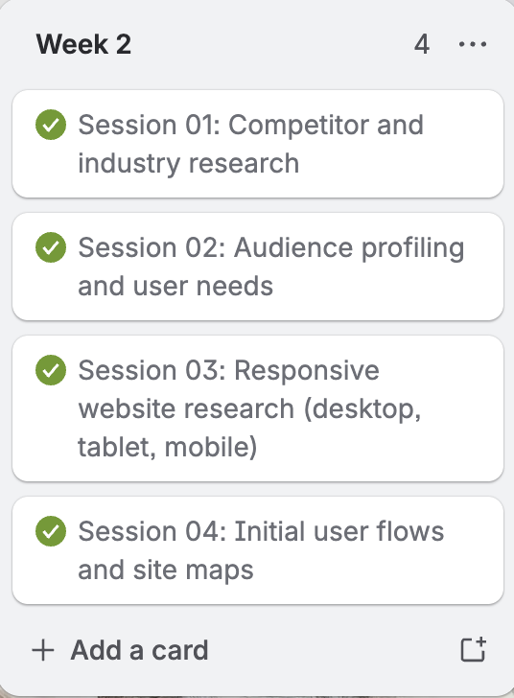

Smart Target
Your smart target should be broken down, providing clear targets for the following week.
Specific: I will create a sitemap and user flow for the Hey Service Group website based on the research I did this week.

Measurable: It will be done when I have a clear map of all the pages and a user journey drawn out on my Figma board.

Achievable: I now understand who the target audience is and what the site needs to include, so mapping out the structure is a realistic next step.

Relevant: This links directly to my planning work and will make it much easier when I start designing the actual pages.
Time-bound: I will have this finished by the end of Week 3 on 20th March 2026.

Week 3 (750 words) | 00/00/00
Reflection | Tutor Feedback
Your weekly reflection should include the following:  - A description of what happened this week. Include screenshots to help explain what you did.  - If you used any software / tools, explain what and why you used it.  - How did you feel this week went. What went well, what did not.  - Were there any issues you had this week and did you find a solution?  - Any further research you did and how did you use it to help you.  - What was your SMART target from last week? Did you complete it? If not why?  - How did my work this week connect to the overall project goals?  - What feedback did I receive, and how did I respond to it?  - What would I do differently next time?  - What are my priorities or goals for next week | Make sure you complete this weeks reflection. Also can you update the 00/00/0000 with the date you have created this reflections
This week I had to finish off some leftover research from last week first — I forgot to do my target audience research in Week 2 so I sorted that out and made a few small additions to other parts of my research as well. Once that was done, I moved on to creating the sitemap.

The sitemap took me longer than I expected. It had been a while since I'd done one so I watched a YouTube video to remind myself how to approach it properly. Once I understood what I needed to do, I mapped out the full structure for both the customer route and the engineer route, showing how all the pages connect.

After the sitemap I moved on to sketching the website on paper. I won't lie — this was harder than I thought. I couldn't get what was in my head onto the page easily. I went through about five attempts on the same page before I finally got something that looked close to what I was imagining. It wasn't exactly perfect but it was close enough to work with.

One thing that really helped me with the sketches was the dashboard research I did in Week 2. Because I'd already looked at how other dashboards display information visually, I knew how to lay out the data in a simple and clean way rather than just filling the screen with text. This made it easier to get all the information the client needed into the dashboard without it looking cluttered.

All the sketches were done in phone screen size first because mobile was the priority layout.
Trello Update
Take a screenshot of your Trello board. This should be updated weekly therefore visually some changes. Write what you had done this week and what changes you have made to the board.
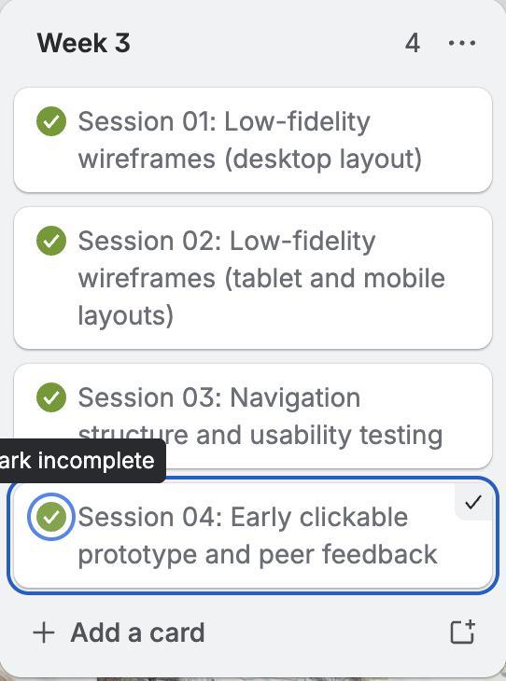

Smart Target
Your smart target should be broken down, providing clear targets for the following week.
Specific: I will start my low-fidelity wireframes in Figma using my sketches and sitemap as a guide, covering the main pages for both user routes.

Measurable: This will be complete when I have at least the key pages wireframed in phone, tablet and desktop sizes on my Figma board.

Achievable: I now have clear sketches and a sitemap to work from so moving into Figma is the natural next step.

Relevant: This is a key planning stage that needs to be done before I can move into high-fidelity designs.

Time-bound: I will have the main pages wireframed by the end of Week 4 on 27th March 2026.

Week 4 (750 words) | 00/00/00
Reflection | Tutor Feedback
Your weekly reflection should include the following:  - A description of what happened this week. Include screenshots to help explain what you did.  - If you used any software / tools, explain what and why you used it.  - How did you feel this week went. What went well, what did not.  - Were there any issues you had this week and did you find a solution?  - Any further research you did and how did you use it to help you.  - What was your SMART target from last week? Did you complete it? If not why?  - How did my work this week connect to the overall project goals?  - What feedback did I receive, and how did I respond to it?  - What would I do differently next time?  - What are my priorities or goals for next week | Can you complete last week reflections
This week I carried out colour and typography research to figure out what would work best for the website. I wanted the colours and fonts to not only match Hey Service Group's brand guidelines but also reflect the kind of professional and clean image I wanted the website to have. I looked at what colours would communicate trust and cleanliness without looking too generic.

After the research I moved into creating my low-fidelity prototype in Figma. I'll be honest — this was probably the hardest part of the whole project for me so far. I personally find it much easier and more enjoyable to code than to sit and design screens in detail. But I pushed through it.

I used Figma frames for iPhone, tablet and desktop. The way I worked through it was to design the phone screen first, then copy it across to the tablet frame and manually adjust the sizes to fit properly, then repeat that process again for the desktop. I did this for every single page, both for the customer route and the engineer route.

It took me a very long time to get through this. I didn't manage to finish all the low-fidelity designs this week and will need to carry it over into the next few weeks. Even though it was frustrating, I made good progress and the structure of the website is becoming a lot clearer as I go through each page.
Trello Update
Take a screenshot of your Trello board. This should be updated weekly therefore visually some changes. Write what you had done this week and what changes you have made to the board.
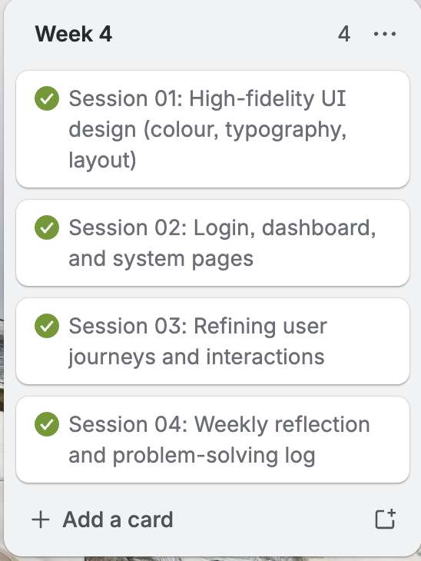

Smart Target
Your smart target should be broken down, providing clear targets for the following week.
Specific: I will continue and aim to complete my low-fidelity wireframes in Figma, finishing off any remaining pages for both the customer and engineer routes.

Measurable: This will be done when all key pages have been wireframed across phone, tablet and desktop sizes.

Achievable: I've already got a strong start and understand the process now so continuing is manageable.

Relevant: Finishing the low-fidelity is essential before I can properly move into high-fidelity designs.
Time-bound: I will aim to have the low-fidelity fully completed before the end of the Easter break.

Week 5 (750 words) | 00/00/00
Reflection | Tutor Feedback
Your weekly reflection should include the following:  - A description of what happened this week. Include screenshots to help explain what you did.  - If you used any software / tools, explain what and why you used it.  - How did you feel this week went. What went well, what did not.  - Were there any issues you had this week and did you find a solution?  - Any further research you did and how did you use it to help you.  - What was your SMART target from last week? Did you complete it? If not why?  - How did my work this week connect to the overall project goals?  - What feedback did I receive, and how did I respond to it?  - What would I do differently next time?  - What are my priorities or goals for next week | First week of easter holidays
Trello Update
Take a screenshot of your Trello board. This should be updated weekly therefore visually some changes. Write what you had done this week and what changes you have made to the board.
Smart Target
Your smart target should be broken down, providing clear targets for the following week.

Week 6 (750 words) | 00/00/00
Reflection | Tutor Feedback
Your weekly reflection should include the following:  - A description of what happened this week. Include screenshots to help explain what you did.  - If you used any software / tools, explain what and why you used it.  - How did you feel this week went. What went well, what did not.  - Were there any issues you had this week and did you find a solution?  - Any further research you did and how did you use it to help you.  - What was your SMART target from last week? Did you complete it? If not why?  - How did my work this week connect to the overall project goals?  - What feedback did I receive, and how did I respond to it?  - What would I do differently next time?  - What are my priorities or goals for next week | Second week of easter holidays
Trello Update
Take a screenshot of your Trello board. This should be updated weekly therefore visually some changes. Write what you had done this week and what changes you have made to the board.
Smart Target
Your smart target should be broken down, providing clear targets for the following week.

Week 7 (750 words) | 00/00/00
Reflection | Tutor Feedback
Your weekly reflection should include the following:  - A description of what happened this week. Include screenshots to help explain what you did.  - If you used any software / tools, explain what and why you used it.  - How did you feel this week went. What went well, what did not.  - Were there any issues you had this week and did you find a solution?  - Any further research you did and how did you use it to help you.  - What was your SMART target from last week? Did you complete it? If not why?  - How did my work this week connect to the overall project goals?  - What feedback did I receive, and how did I respond to it?  - What would I do differently next time?  - What are my priorities or goals for next week | Please can you complete last week website
This week I focused on finishing off my low-fidelity designs in Figma. Even though I had already built the website during the Easter break, I knew I still needed to complete the low-fidelity and high-fidelity work as part of the project requirements, so I made sure to get that done properly this week.

I also did some small improvements to the website itself — little things I spotted that needed fixing or could be done better.

The other main thing I did this week was prepare a PowerPoint presentation for the upcoming client visit from Hey Service Group in Week 8. I wanted to make sure I was properly ready to show them my work and explain the decisions I'd made throughout the project. I put together slides covering my research, design process, and the website itself so I could walk them through everything clearly.

Overall this week was quite productive. I felt a bit more relaxed because the website was already in a good place, so I could focus on tying up loose ends without feeling too stressed.
Trello Update
Take a screenshot of your Trello board. This should be updated weekly therefore visually some changes. Write what you had done this week and what changes you have made to the board.
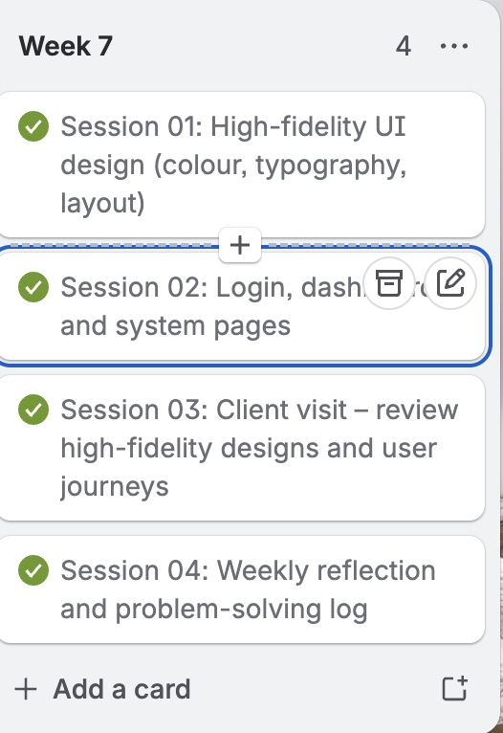

Smart Target
Your smart target should be broken down, providing clear targets for the following week.
Specific: I will present my work to Hey Service Group during the client visit next week and act on any feedback they give me.

Measurable: This will be done when the presentation has been delivered and I have a written list of feedback from the client that I can action.

Achievable: My PowerPoint is prepared and the website is in a good place so I am ready for the visit.

Relevant: Getting real client feedback is a key part of the project and will help improve the final outcome.

Time-bound: The client visit takes place in Week 8 and feedback to be documented the same day.

Week 8 (750 words) | 00/00/00
Reflection | Tutor Feedback
Your weekly reflection should include the following:  - A description of what happened this week. Include screenshots to help explain what you did.  - If you used any software / tools, explain what and why you used it.  - How did you feel this week went. What went well, what did not.  - Were there any issues you had this week and did you find a solution?  - Any further research you did and how did you use it to help you.  - What was your SMART target from last week? Did you complete it? If not why?  - How did my work this week connect to the overall project goals?  - What feedback did I receive, and how did I respond to it?  - What would I do differently next time?  - What are my priorities or goals for next week | Can you complete this and update the date
This week had two big things happening — the client visit from Hey Service Group and continuing my high-fidelity designs.

The client visit was on Wednesday. I showed them the live website and presented my PowerPoint that I had prepared in Week 7. The client gave me feedback on things they felt could improve the website. Some of the suggestions I was able to implement, but some I couldn't because of limitations I had with the data and resources available to me. Overall the client said the presentation was clear and concise, and that I was confident and clearly understood what they needed. That was really encouraging to hear.

After the visit we also got more detailed written feedback from both our tutor and Hey Service Group on how our overall project was progressing and what they wanted to see improved. I made notes on all of it and started working through the changes I could make.

I also had a bit of mental stress this week because I'd already built the website and part of me felt like there wasn't much point in continuing the high-fidelity designs in Figma. But with some encouragement from my tutor and myself, I pushed through it. I finished off the low-fidelity and got started on the high-fidelity designs properly.

On top of all that, I carried out sustainability research this week. In Week 7 I had mentioned briefly how much carbon websites can use. This week I went deeper into it — researching why websites produce so much carbon and how you can reduce it. This took me around two hours and then I got back to focusing on the high-fidelity designs.
Trello Update
Take a screenshot of your Trello board. This should be updated weekly therefore visually some changes. Write what you had done this week and what changes you have made to the board.
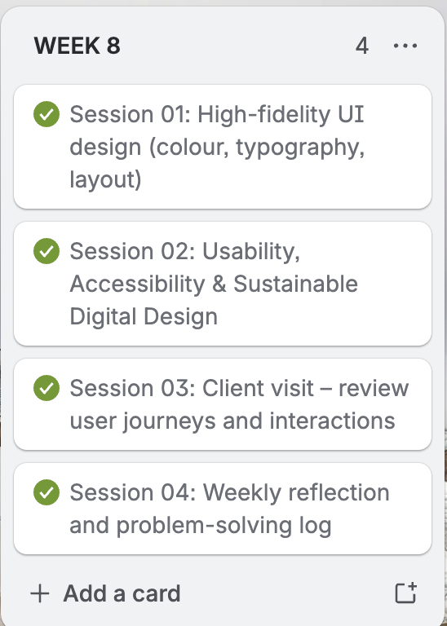

Smart Target
Your smart target should be broken down, providing clear targets for the following week.
Specific: I will continue building out my high-fidelity designs in Figma and start implementing the feedback from the client visit into both the designs and the website.

Measurable: This will be done when I have high-fidelity screens for the main pages completed and the key pieces of client feedback have been acted on.

Achievable: I now have clear feedback and a better sense of what the final product needs to look like.

Relevant: High-fidelity designs and acting on client feedback are both required parts of the project submission.

Time-bound: I aim to have the main high-fidelity pages done and feedback actioned by the end of Week 9 on 8th May 2026.

Week 9 (750 words) | 00/00/00
Reflection | Tutor Feedback
Your weekly reflection should include the following:  - A description of what happened this week. Include screenshots to help explain what you did.  - If you used any software / tools, explain what and why you used it.  - How did you feel this week went. What went well, what did not.  - Were there any issues you had this week and did you find a solution?  - Any further research you did and how did you use it to help you.  - What was your SMART target from last week? Did you complete it? If not why?  - How did my work this week connect to the overall project goals?  - What feedback did I receive, and how did I respond to it?  - What would I do differently next time?  - What are my priorities or goals for next week | Can you complete this and update the date
This was really the final push of the project. This week was supposed to be mainly about finalising the high-fidelity designs but I was also still improving the website at the same time.

I made a lot of improvements to the website this week. I made the password system more secure and faster to use, and I added a forgot password feature. I also added a create account option which lets users add their username, email and password to the database — but I made sure this was only available for users and not for engineers.

I also made it so that when a new company creates an account, generic data shows up for their site automatically and their company name displays correctly. This was done using Python on the backend.

On top of that I made changes to the engineer side of the dashboard, specifically improving the notification system, the engineer profile section, and making it so that when an engineer creates a new site for a company, that site gets a set of random placeholder data to show.

While all this was going on I was also pushing forward with the high-fidelity designs in Figma. It was a busy week but a productive one.
Trello Update
Take a screenshot of your Trello board. This should be updated weekly therefore visually some changes. Write what you had done this week and what changes you have made to the board.
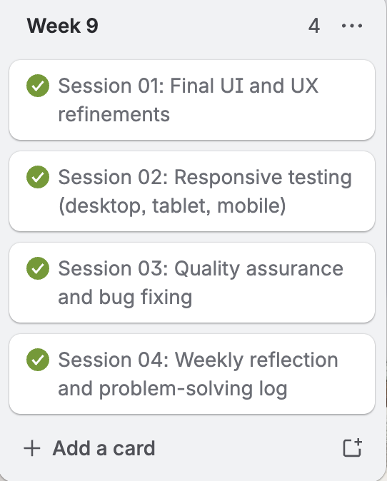

Smart Target
Your smart target should be broken down, providing clear targets for the following week.
Specific: I will finalise my high-fidelity designs in Figma, complete my testing document, and carry out peer and tutor feedback on the website.

Measurable: This will be done when all main pages are in high-fidelity, the testing document is filled in, and I have written feedback from at least one peer and my tutor.

Achievable: The website is in a strong place and the high-fidelity is progressing well so this is a realistic target.

Relevant: Testing and feedback are required parts of the submission and high-fidelity is one of the key deliverables.

Time-bound: To be completed by the end of Week 10 on 15th May 2026.

Week 10 (750 words) | 00/00/00
Reflection | Tutor Feedback
Your weekly reflection should include the following:  - A description of what happened this week. Include screenshots to help explain what you did.  - If you used any software / tools, explain what and why you used it.  - How did you feel this week went. What went well, what did not.  - Were there any issues you had this week and did you find a solution?  - Any further research you did and how did you use it to help you.  - What was your SMART target from last week? Did you complete it? If not why?  - How did my work this week connect to the overall project goals?  - What feedback did I receive, and how did I respond to it?  - What would I do differently next time?  - What are my priorities or goals for next week | Can you complete this and update the date
This week I focused on finalising both my low-fidelity and high-fidelity designs and making sure everything on the website was working properly.

I carried out a lot of testing this week and filled in my testing document. I tested the website across different screen sizes — phone, tablet and desktop — to make sure the layout adjusted correctly on each one and nothing was being cut off or overlapping. I also tested the light and dark mode toggle to check that everything was readable in both modes and that colours were displaying correctly without anything being hard to see.

I added the dark mode toggle this week because I realised not everyone wants to use a bright white website. I also made it remember which mode the user prefers — so if someone has visited before and chose dark mode, it will automatically load in dark mode the next time they visit on that device.

I tested the login and authentication system thoroughly — making sure incorrect credentials were rejected, correct ones worked, and that users and engineers were directed to the right dashboards after logging in. I also tested form validation, making sure empty fields and incorrect formats were flagged properly.

I asked my peers and tutor for feedback on the website. The feedback was mostly positive. My tutor did notice one issue — the logo was changing size when switching between light and dark mode — and I fixed that straight away.

I also tested all navigation links to make sure nothing was broken, checked that the traffic light indicators were displaying correctly, and made sure the engineer-only features were not accessible from the customer route.
Trello Update
Take a screenshot of your Trello board. This should be updated weekly therefore visually some changes. Write what you had done this week and what changes you have made to the board.
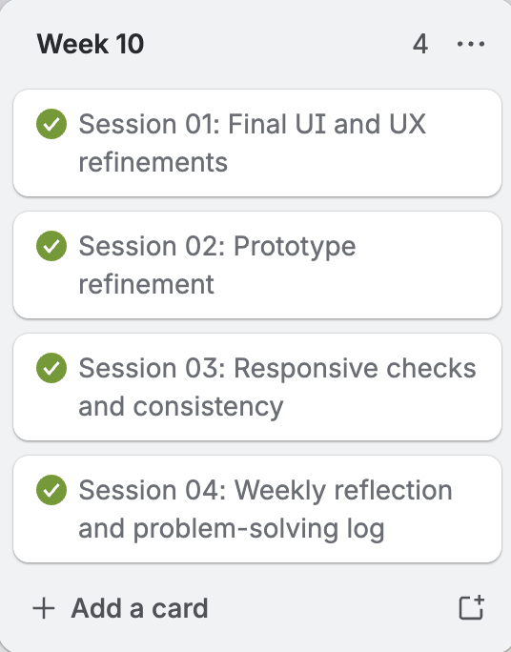

Smart Target
Your smart target should be broken down, providing clear targets for the following week.
Specific: I will organise all my project files properly, prepare my final presentation, and get everything ready for submission.

Measurable: This will be done when all files are named correctly, folders are organised, and my final presentation is ready to deliver.

Achievable: The website and designs are finished so this final organisation and presentation prep is a realistic last step.

Relevant: File organisation and the final presentation are both required parts of the submission.

Time-bound: To be completed by the end of Week 11 on 22nd May 2026.

Week 11 (750 words) | 00/00/00
Reflection | Tutor Feedback
Your weekly reflection should include the following:  - A description of what happened this week. Include screenshots to help explain what you did.  - If you used any software / tools, explain what and why you used it.  - How did you feel this week went. What went well, what did not.  - Were there any issues you had this week and did you find a solution?  - Any further research you did and how did you use it to help you.  - What was your SMART target from last week? Did you complete it? If not why?  - How did my work this week connect to the overall project goals?  - What feedback did I receive, and how did I respond to it?  - What would I do differently next time?  - What are my priorities or goals for next week | Can you complete this and update the date
This was the final week of the project and it was a busy one. I spent time making sure all my HTML files were properly named and all my files and images were organised correctly in folders so everything was clean and easy to navigate.

I also created my final PowerPoint presentation for college. This was to present all my work to my tutors, the head of department, and Hey Service Group — showing everything I had done throughout the project and the final outcome.

I had to prepare to present everything in under 10 minutes, which was challenging because there was so much I wanted to show — the extras I had added, the Python backend, and how the whole system worked. But I made the decision to focus on the front end of the website and explain clearly why I made certain design and development choices, including why I couldn't implement some of the feedback I had received.

The presentation itself went really well. I presented confidently and clearly without rushing. The next day I got feedback from the head of department and from Hey Service Group saying they liked how I presented my work and that they were impressed with how the website looked and the improvements I had made. My tutor also gave me feedback after the presentation on what I had done well.

That feedback was a massive encouragement to finish the project on a high.
Trello Update
Take a screenshot of your Trello board. This should be updated weekly therefore visually some changes. Write what you had done this week and what changes you have made to the board.
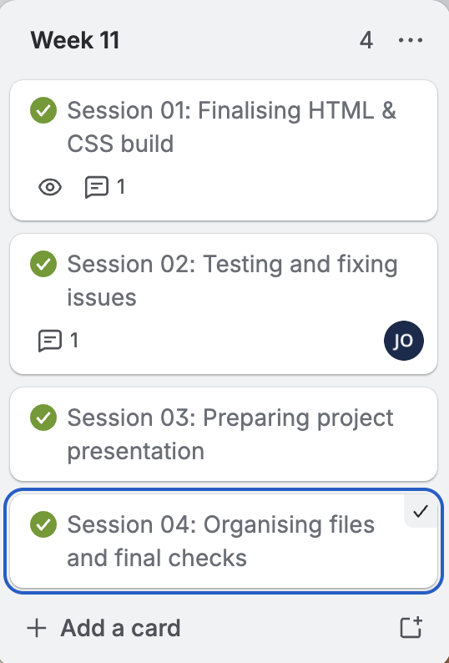

Smart Target
Your smart target should be broken down, providing clear targets for the following week.
Specific: I will complete all final checks, submit my work on Teams, and ensure all submission folders are correctly organised with everything in the right place.

Measurable: This will be complete when all folders have been submitted on Teams before the 5pm deadline on 22nd May 2026.

Achievable: Everything is done — this is just the final admin and submission step.

Relevant: Submitting on time and in the correct format is the final requirement of the project.
Time-bound: All work to be submitted by Friday 22nd May 2026 at 5pm GMT.

Final Evaluation
Your final evaluation should consist of the following:
Reflections on your idea
- What inspired your initial concept, and how did it develop over time?
- Which parts of your idea worked the best, and why do you think they were effective?
- Were there any aspects of your idea that didn’t translate as expected? What would you change next time?
- How did feedback from others influence your idea during the process?
Reflections on your research?
- Which sources or references had the biggest impact on your creative decisions?
- How did your research help you solve problems or improve your work?
- Were there any areas where you needed more research, and how might that have helped?
- How did you apply research directly into your designs or project outcome?
Reflections on your planning & production?
- How well did your plan support your workflow and deadlines?
- What challenges did you face during production, and how did you overcome them?
- Did you adapt your plan at any stage — if so, what caused this change?
- Which tools, techniques, or processes helped you most, and why?
Final Product reflections?
- How well does your final outcome meet the original brief or purpose?
- What elements are you most proud of, and what makes them successful?
- Are there areas of the final product that you would refine or redesign if given more time?
- How did user feedback, peer critique, or testing influence your final decisions?
Reflections on your learning?
- What new skills or knowledge did you gain during this project?
- How did your approach or mindset change from the beginning to the end?
- Which mistakes or challenges taught you the most, and why?
- How will you apply what you’ve learnt to your next project?

Reflections on My Idea
When I first got the brief from Hey Service Group I honestly thought it was just going to be a normal company website. But once I sat down and actually read through what they do and what they needed, I realised it was a lot more than that. They work in industrial vent cleaning and fire safety, so the website had to do something useful for their clients, not just look good. That's how the idea of having two separate routes came about — one for the customer and one for the engineer. Each one needed different information and a different level of access.
The thing that worked best in the whole project was the dashboard. From when I was doing my research in Week 2, I noticed that most websites in this industry had too much text and were hard to read quickly. I wanted the opposite of that. I used visual indicators and simple layouts so that someone could open the dashboard and immediately understand what was going on with their system without having to read through loads of information. The traffic light system — red, amber, green — was the clearest way to do that and I'm really proud of how it came out.
The hardest part of the whole project for me was the Figma design work — the low-fidelity and high-fidelity prototypes. I'm not going to lie, I find coding so much easier than sitting and designing screens. There were moments, especially in Week 8, where I was struggling mentally because I had already built the website and it felt pointless to keep doing the design work in Figma. But my tutor encouraged me to push through it and I'm glad I did.
The client feedback really shaped the project. When Hey Service Group came in during Week 8 they pointed out things I hadn't thought about and gave me a clearer picture of what they actually wanted. Some of their suggestions I was able to implement, some I couldn't because of data and resource limitations, but I made sure to explain that in my presentation.
Reflections on My Research
The research that helped me the most was looking at dashboards on Apple and Dribbble in Week 2. That directly changed how I approached the dashboard design. I could see how they used visuals and clean layouts to display information quickly and I knew that was the direction I wanted to go. It gave me confidence in the design decisions I was making.
The competitor research was also really useful. Most companies in this industry have outdated and cluttered websites with too much text. Seeing that made it clear what I needed to do differently — keep it clean, reduce the words, and make sure the most important information was visible straight away.
Doing the target audience research, even though I forgot to do it in Week 2 and had to carry it over to Week 3, was important. It made me realise that the people using this website are not everyday consumers — they're facilities managers, restaurant owners and property supervisors who need to find information quickly. That changed how I thought about the layout and what to put above the fold.
One thing I would do differently is research code optimisation and file compression earlier. I only really looked into sustainability properly in Week 8 when I spent about two hours researching how much carbon websites produce and how to reduce it. If I had done that research earlier I would have built the website more efficiently from the start.
Reflections on My Planning and Production
Setting up Trello in Week 1 was one of the best things I did. It kept me organised throughout the whole project and meant I always knew what I was supposed to be working on each week. Without it I think I would have jumped into things too early or lost track of where I was.
The Easter break was massive for me. Having two weeks to focus entirely on building the website without any other distractions meant I could really get into the coding. I used HTML, CSS, JavaScript and Python to build the full website including the backend. Because coding is where I feel most comfortable, those two weeks are where I made the most progress.
The Figma side of things was a challenge throughout. I started the low-fidelity in Week 4 and didn't finish it until Week 7 because I kept prioritising the website over the designs. The way I worked through Figma was to design the phone screen first, then copy it to the tablet frame and adjust the sizes, then repeat for desktop. I did that for every page on both routes which took a very long time.
The client visits in Week 8 also required me to shift my plans. I had to prepare a presentation and act on their feedback rather than just continuing to build. But that ended up being a really good experience and helped improve the final website.
Reflections on My Final Product
I think the final website goes beyond what the brief asked for. It has the two user routes the client needed — customer and engineer — both with proper login systems, dashboards and relevant information for each type of user. It's fully responsive across phone, tablet and desktop. But on top of that I added extra features that weren't strictly required — a dark mode toggle that remembers your preference, a forgot password system, a create account feature that adds users to the database, a notification system for engineers, and dynamic data that loads when a new company creates an account. All of that was built using Python on the backend.
I'm most proud of how complete and functional it is. It's not just a prototype or a mock-up — it actually works. You can log in, access the dashboard, see real data and navigate between pages properly. That was always my goal from the beginning and I'm glad I got there.
If I had more time I would improve the filtering on the engineer dashboard so they could sort sites by region or status more easily, and I would also work more on the mobile version of the engineer route.
The feedback I received throughout — from peers, my tutor and the client — all helped shape the final product. My tutor noticed the logo size issue when switching between light and dark mode and I fixed that. The client gave feedback during their visits that led to improvements in how information was presented. And peer feedback helped me catch smaller issues I had missed.
Reflections on My Learning
This project taught me more than any other project I have done. Technically I got a lot more confident with Python, especially using it for authentication, database management and dynamic data. I also improved a lot in how I write clean and responsive HTML and CSS. And even though I found it difficult, I did improve in Figma — by the end of the project I was working through it much faster than I was in Week 3.
But the biggest thing I learned was what a full project actually looks like from start to finish — going from a client brief, through research, planning, design, building, testing and presenting. I had never done all of those stages properly in one project before. Going through the whole process showed me how important each stage is, even the ones that feel slow or pointless at the time like the low-fidelity designs.
My mindset changed a lot from the beginning to the end. At the start I just wanted to get to the coding part. By the end I understood why the research and design stages matter and how they actually make the coding stage easier and better. I won't skip those stages next time.
The thing that taught me the most was probably the mental challenge in Week 8 — when I had already built the website and had to push myself to finish the Figma work anyway. Learning to keep going even when something feels unnecessary is a skill that will help me in any future project or job.

